Laboratoriya ishi №9
Mavzu: CSS media queries orqali responsiv dizayn
yaratish
Fan: Web ilovalar

1. Ishdan maqsad
Veb-sahifalarni turli ekran o‘lchamlariga (kompyuter, planshet, telefon) moslashuvchi qilib yaratish uchun CSS media queries texnologiyasidan foydalanishni o‘rganish.

2. Nazariy qism
Responsiv dizayn — bu veb-sahifaning foydalanuvchi ekran o‘lchamiga qarab o‘z shaklini, joylashuvini va elementlarning o‘lchamini avtomatik tarzda o‘zgartiruvchi dizayn usulidir.
Media queries — CSS da turli qurilmalarga qarab maxsus uslublarni qo‘llash imkonini beruvchi mexanizm.
Asosiy sintaksis:
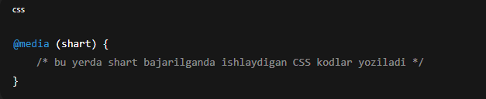Ko‘p ishlatiladigan media query turlari:
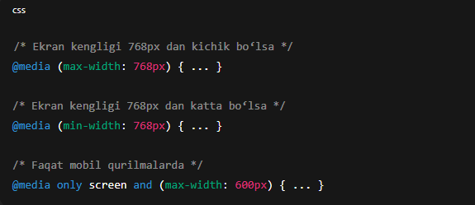

3. Amaliy qism

3.1. HTML fayl (index.html)
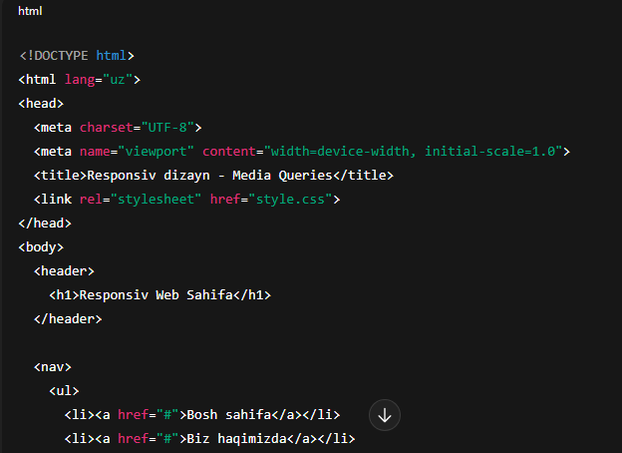
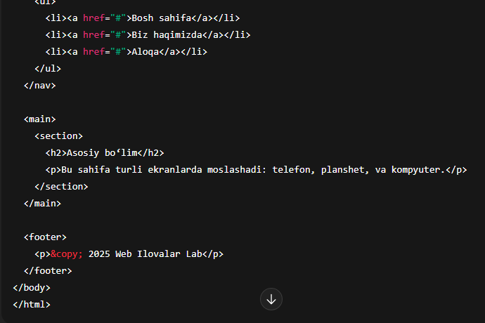

3.2. CSS fayl (style.css)
/* Umumiy uslublar */body {
font-family: Arial, sans-serif;
margin: 0;
padding: 0;
}
header, footer {
background-color: #007bff;
color: white;
text-align: center;
padding: 15px;
}
nav ul {
list-style-type: none;
display: flex;
justify-content: center;
background: #f0f0f0;
padding: 10px;
}
nav li {
margin: 0 15px;
}
main {
padding: 20px;
text-align: center;
}
/* Planshet (768px gacha) */@media (max-width: 768px) {
nav ul {
flex-direction: column;
align-items: center;
}

nav li {
margin: 10px 0;
}
}
/* Telefon (480px gacha) */@media (max-width: 480px) {
header, footer {
padding: 10px;
font-size: 14px;
}

main {
font-size: 14px;
}

nav ul {
padding: 0;
}
}

4. Natija
Ushbu kodni ishga tushirganda:
*Kompyuterda menyu gorizontal holatda ko‘rinadi.
*Planshetda menyu elementlari vertikalga o‘tadi.
*Telefon ekranida esa matn va elementlar kichikroq o‘lchamda joylashadi.
Natijada: sayt barcha ekran o‘lchamlariga moslashadi.
Topshiriq: Xiva shahri sayti
HTML
<!DOCTYPE html>
<html lang="uz">
<head>
<meta charset="UTF-8">
<meta name="viewport" content="width=device-width, initial-scale=1.0">
<title>Xiva Shahri</title>
<link rel="stylesheet" href="style.css">
</head>
<body>

<header>
<h1>Xiva shahri</h1>
<p>Sharqning bebaho durdonasi</p>
</header>

<nav>
<ul>
<li><a href="#">Bosh sahifa</a></li>
<li><a href="#">Tarix</a></li>
<li><a href="#">Ichan-Qal’a</a></li>
<li><a href="#">Aloqa</a></li>
</ul>
</nav>

<section class="hero">
<h2>Ichan-Qal’a — Xivaning yuragi</h2>
<p>Dunyo merosi ro‘yxatiga kiritilgan tarixiy shahar.</p>
</section>

<section class="cards">
<div class="card">
<h3>Kalta Minor</h3>
<p>Xivaning eng mashhur minorasi bo‘lib, ko‘k koshinlari bilan mashhur.</p>
</div>

<div class="card">
<h3>Juma masjidi</h3>
<p>200 dan ortiq yog‘och ustunlari bilan Sharq me’morchiligining noyob namunasi.</p>
</div>

<div class="card">
<h3>Toshhovli saroyi</h3>
<p>Xonlar yashagan hashamatli saroy — naqshlar bilan bezatilgan ajoyib obida.</p>
</div>
</section>

<footer>
<p>&copy; 2025 Xiva shahri sayti. Barcha huquqlar himoyalangan.</p>
</footer>

</body>
</html>
SCC
/* GLOBAL STYLE */
body {
margin: 0;
font-family: Arial, sans-serif;
background: #f4f4f4;
}

header {
background: #1e81b0;
padding: 25px;
text-align: center;
color: white;
}

nav {
background: #144474;
}

nav ul {
display: flex;
justify-content: center;
padding: 0;
margin: 0;
list-style: none;
}

nav ul li a {
color: white;
text-decoration: none;
padding: 15px 20px;
display: block;
}

nav ul li a:hover {
background: #1e81b0;
}

/* HERO SECTION */
.hero {
background: url('https://upload.wikimedia.org/wikipedia/commons/thumb/6/64/Khiva_Ichan_Qala_15-09.JPG/640px-Khiva_Ichan_Qala_15-09.JPG')
center/cover no-repeat;
color: white;
text-align: center;
padding: 80px 20px;
}

.cards {
display: flex;
justify-content: center;
gap: 20px;
margin: 30px;
}

.card {
background: white;
padding: 20px;
border-radius: 10px;
width: 30%;
box-shadow: 0 2px 10px rgba(0,0,0,0.1);
text-align: center;
}

footer {
background: #333;
color: white;
padding: 20px;
text-align: center;
margin-top: 20px;
}

/* ============================================
📱 TELEFON UCHUN (max-width: 768px)
============================================ */
@media (max-width: 768px) {

nav ul {
flex-direction: column;
text-align: center;
}

.cards {
flex-direction: column;
margin: 10px;
}

.card {
width: 100%;
}

.hero {
padding: 50px 10px;
font-size: 18px;
}
}

/* ============================================
📲 PLANSHET UCHUN (769px – 1024px)
============================================ */
@media (min-width: 769px) and (max-width: 1024px) {
.cards {
flex-wrap: wrap;
}

.card {
width: 45%;
}
}

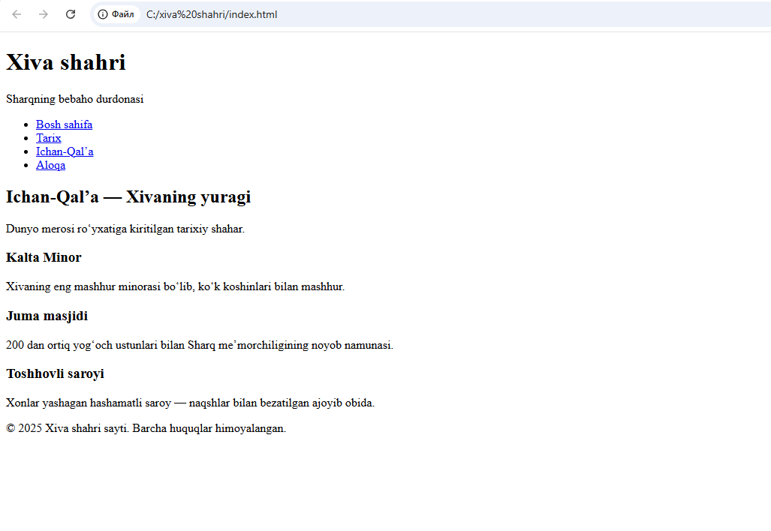

5. Xulosa
Ushbu laboratoriya ishida CSS media queries yordamida veb-sahifani responsiv (moslashuvchan) qilish yo‘llari o‘rganildi. Ushbu yondashuv mobil qurilmalarda foydalanuvchi tajribasini yaxshilaydi va dizaynning universalligini ta’minlaydi.

